# AnaplanConnect Interface

This document will outline the features of the PowerShell scripts that are used as wrappers to the standard AnaplanConnect scripts. These PowerShell scripts will enable the following features:

* A file watcher that waits for the arrival of files to start importing into Anaplan that can run through Enterprise Schedulers
* Copy/move, import and backup the source files as required after the Success or Failure of the import
* Provide email notifications of the outcome of the processes
* Optionally can be used to trigger Actions on Anaplan that do not have file operations, but as required through schedulers

## Contents of the ZIP file

The contents of the ZIP file are:

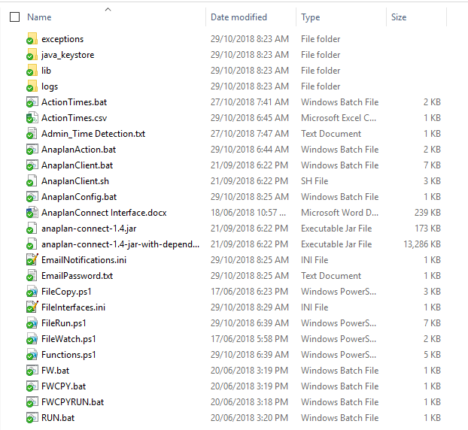

|  |  |
| --- | --- |
| Object | Comments |
| *exceptions* | Folder to hold the errors/messages generated from AnaplanConnect |
| *java_keystore* | Folder to hold the Java KeyStore file for CA Certificate authentication  See: <https://s3.amazonaws.com/anaplanenablement/Community/Anapedia/Anaplan_Connect.pdf> |
| *lib* | Folder that holds the required Java libraries to run AnaplanConnect |
| *logs* | Folder to hold the logging information of the PowerShell scripts |
| *AnaplanClient.bat*  *anaplan-connect.jar* | AnaplanConnect script and Java package |
| *AnaplanConfig.bat* | The connection details for Anaplan (i.e. Basic Authentication or CA Cert details) |
| *Anaplan_Action.bat* | Main script that runs the various types of Anaplan Actions |
| *FileInterface.ini* | Config file for all file-based operations |
| *FileWatch.ps1*  *FileCopy.ps1*  *FileRun.ps1*  *Functions.ps1* | Main PowerShell scripts for all operations |
| *FW.bat*  *FWCPY.bat*  *FWCPYRUN.bat*  *RUN.bat* | Windows batch scripts that can be used to call the main PowerShell scripts through Enterprise Schedulers |
| *EmailNotifications.ini* | Config file for email notification settings |
| *EmailPassword.txt* | Config file to hold the encrypted password for SMTP authentication |

## Step 1 – AnaplanConnect Authentication

The following file should be updated as required to denote the connection type to Anaplan. The connection can be either one of the two possible types:

1. Basic Authentication: Anaplan Username & Password, where the password is maintained by Anaplan and the Anaplan Username is set to be an Exception user for SSO workspaces. The password will need to be reset every 90days.
2. CA Certificate Authentication: A client certificate procured using a Certification Authority that is attached to the Anaplan Username (see: <https://help.anaplan.com/anapedia/Content/Administration_and_Security/Tenant_Administration/Security/Certificates.htm>)

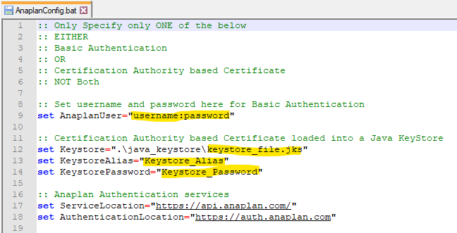

## 

## Step 2 – Email configuration

The following steps need to be complete for email notifications.

1. Update the ***EmailNotifications.ini*** file with the SMTP parameters

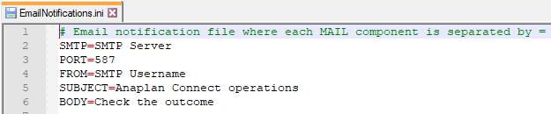

1. As required create the encrypted password file ***EmailPassword.txt*** for the SMTP authentication

To use the default encryption of PowerShell the following command can be issued in the PowerShell prompt and redirect the output to a file as:

"smtpPassword" | ConvertTo-SecureString -AsPlainText -Force | ConvertFrom-SecureString | Out-File ".\EmailPassword.txt"

## Step 3 – File import configuration

This is the main configuration file for all the file import operations. The ***FileInterface.ini*** file will have the following information:

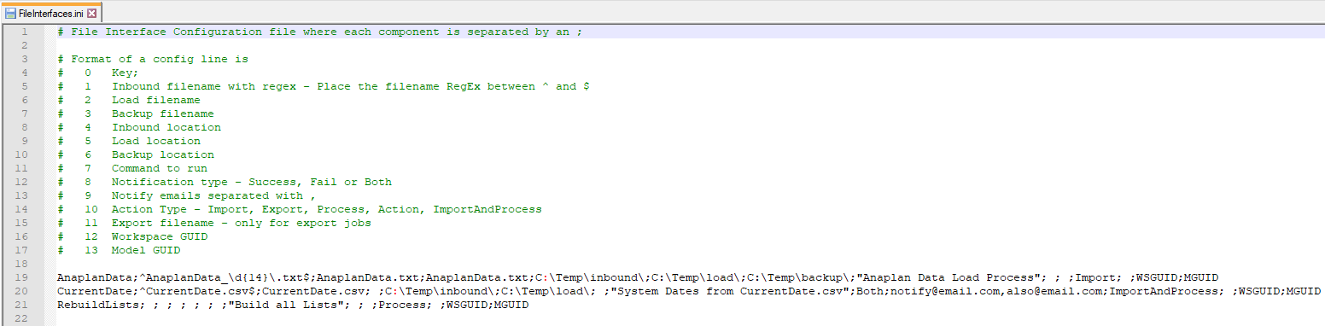

|  |  |
| --- | --- |
| Config Entry | Comments |
| *Key* | **Mandatory** – The main parameter passed to the scripts that picks all the details of the operations |
| *Inbound filename* | **Optional** – The inbound filename as a Regular Expression, so that it can recognise any timestamps |
| *Load filename* | **Optional** – The filename the Anaplan Action is tied to |
| *Backup filename* | **Optional** – The filename the file should be backed-up as |
| *Inbound location* | **Optional** – The folder the file arrives to from a source system |
| *Load location* | **Optional** – The folder the file moves from the inbound location |
| *Backup location* | **Optional** – The folder where the backups lie, which is by date stamped subfolders |
| *Command to run* | **Mandatory** – The Anaplan Action |
| *Notify* | **Optional** – One of Success, Fail or Both |
| *Notify email addresses* | **Optional** – The email addresses comma (,) separated |
| *Action Type* | **Mandatory** – One of Import, Export, Process, Action or ImportAndProcess |
| *Export filename* | **Optional** – Only for Export Action Type |
| *Workspace GUID* | **Mandatory** – Workspace ID |
| *Model GUID* | **Mandatory** – Model ID |

**Note**: The sample file includes example on how the entries should be written.

## Calling the scripts

The scripts can be called manually or via an Enterprise Scheduler. The ***Key*** should be passed as the argument. The following scenarios can be provided as examples of these operations.

1. Wait for an arrival of a file, then import it to Anaplan

FWCPYRUN “Key”

1. Run an Anaplan action per schedule

RUN “Key”

## Email notifications

If an email notification is enabled per config entry, a sample with an attachment of any exceptions generated will look like:

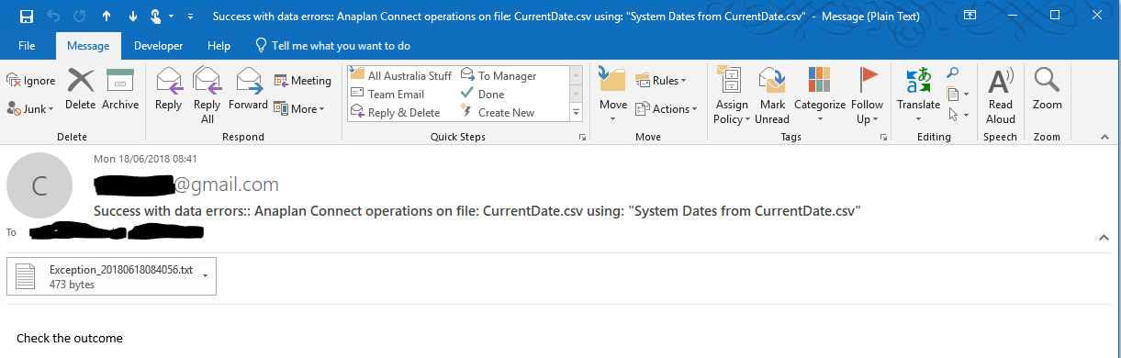

**Note**: The email will contain 1 of 3 statues

1. Success – No issues
2. Success with data errors – Import was successful, but some data items had issues. There will be an attachment with the details of the exceptions generated from Anaplan
3. Fail – The import failed, details will be attached in the email

## Logging

All steps of the interface processes will be logged in the ***logs*** folder for each operation (i.e. ***FileWatch***, ***FileCopy*** and ***FileRun***) separately. The generated exceptions will be in the ***exceptions*** folder.

**Note**: There is no process to clean-up the older log files, which should be done on a case-by-case basis.